Table of discounting factors
Present value of 1 taking into account the interest rate r and number of years n

Interest rate r [%]
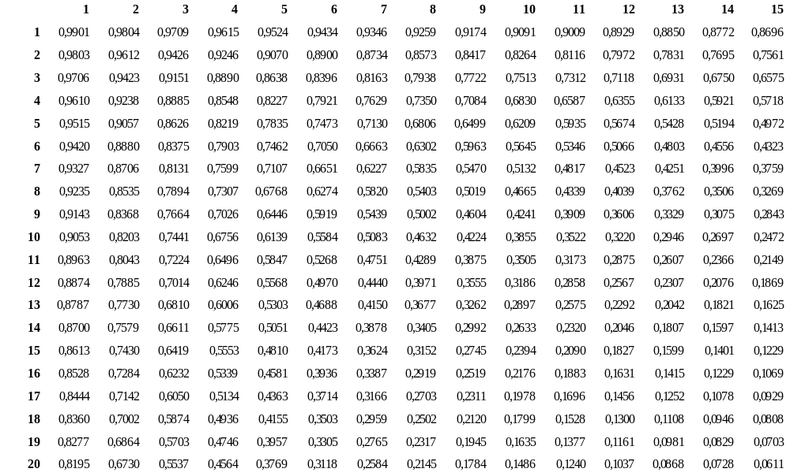
Y
e
a
r
s

Interest rate r [%]
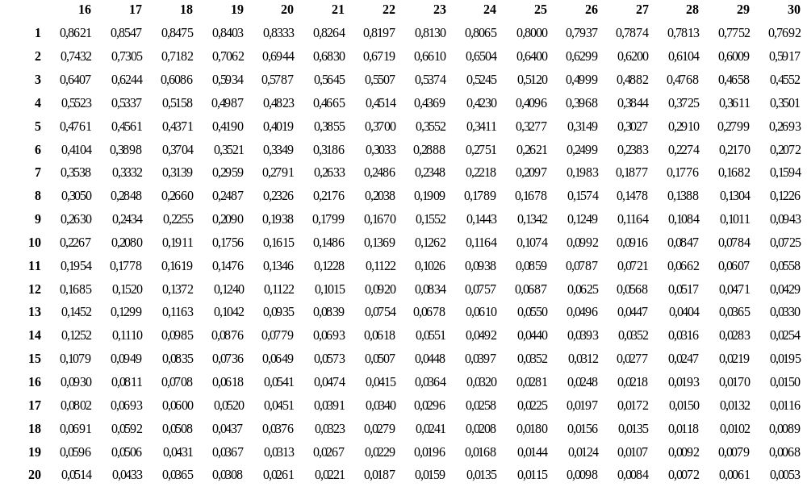
Y
e
a
r
s

